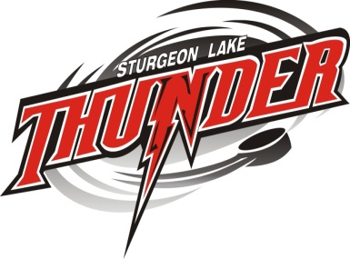
SECOND ANNUAL
GOLF SCRAMBLE
BYRNELL GOLF CLUB
SEPTEMBER 16TH, 2017
SHOT GUN START AT 12:00 PM
4 PERSON SCRAMBLE WITH A MAX AMOUNT OF 72 PLAYERS
ENTRY FEE $50.00 PER PERSON $200.00 PER TEAM REGISTRATION TO BE PAID IN ADVANCE ON OR BEFORE SEPTEMBER 15th 2017
LUNCH IS INCLUDED WITH TEAM REGISTRATION, LUNCH ORDERS ARE REQUIRED WITH REGISTRATION
SPECTATOR LUNCH IS $ 10.00 PER PERSON CHOICES ARE: HOT DOGS, HAMBURGER OR SAUSAGE WITH CAESAR SALAD
BEVERAGES ARE NOT INCLUDED

PLEASE CALL: BYRNELL GOLF CLUB FOR CART RESERVATION 1-705-887-2935
22 – TWO SEATER CARTS ARE AVAILABLE AT 10.00 PER PERSON; CARTS MUST BE RESERVED IN ADVANCE
LAST DAY TO ENTER IS SEPTEMBER 15th2017
CONTEST
BEAT THE PRO HOLE IN ONE CRAZY DRESSED GOLFER

HOLE SPONSOR/$100 |  | PHONE:
BUSINESS NAME:
DOOR PRIZE DONATION |  | PHONE:
BUSINESS NAME:

HURRY TO GET YOUR TEAM REGISTRATION IN, SPACE IS LIMITED REGISTRATION CONTACT: MELITA ANDREWS AT MELITAHAYTER@GMAIL.COM WITH TEAM REGISTRATION & CHEQUE PAYABLE TO:
STURGEON LAKE MINOR HOCKEY ASSOCIATION BOX 427 FENELON FALLS, ON K0M 1N0

